**Import Library Files**

**Step 1 : Library Files**

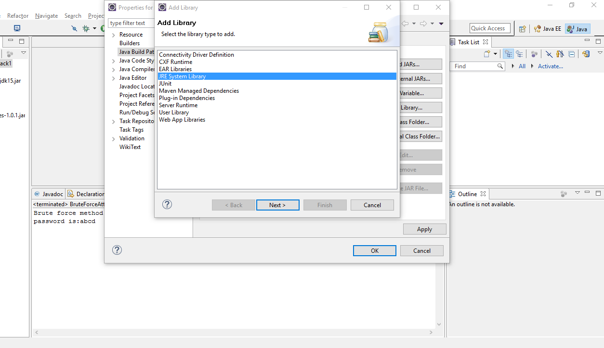

**Step 2**

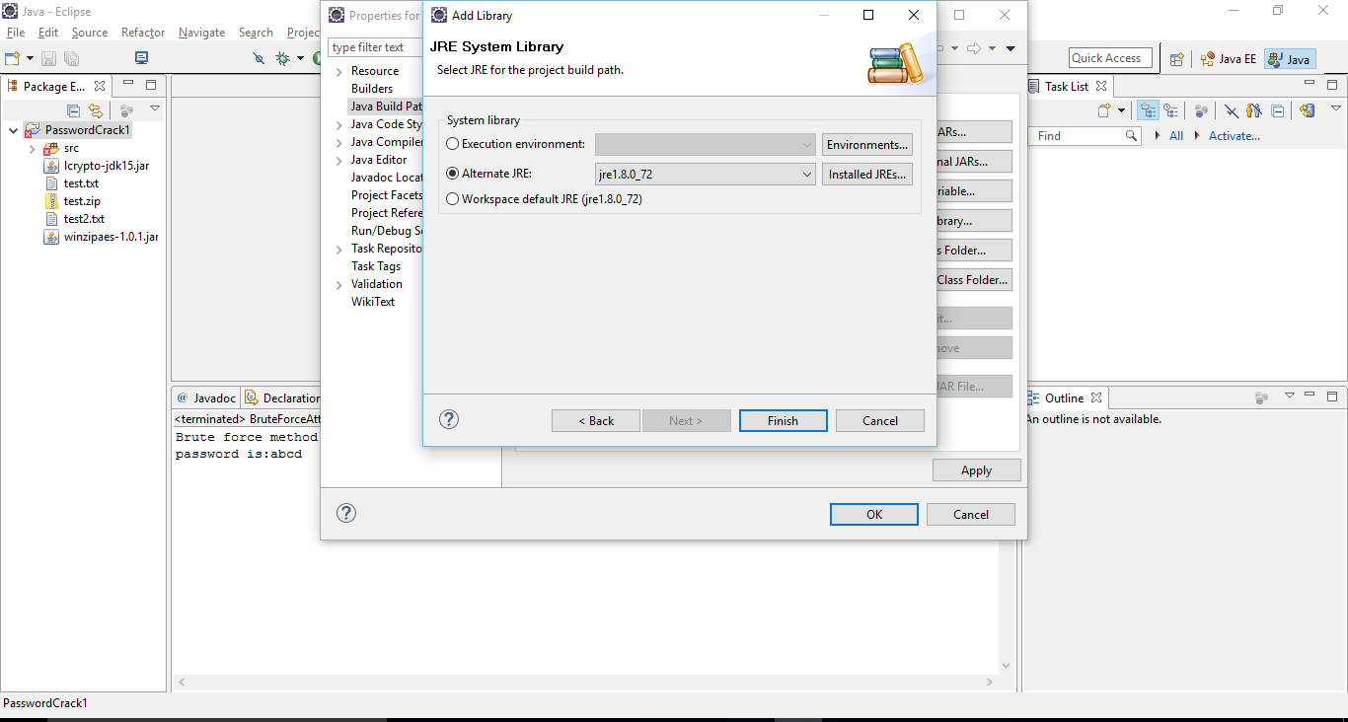

**Step 3: Addition of External Jars**

**ICrypto-jdk 15 and winzipaes-1.0.1**

